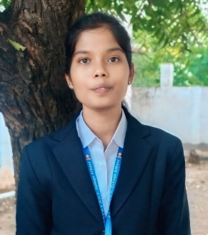
Name: Shubhada Chandrakant Gholap
Email-id: shubhadagholap408@gmail.com
Phone no:7795717155
Career objective:
Motivated BCA student with skills in programming and web development, seeking internship or entry-level opportunity to leverage knowledge in software and web development while contributing to organizational success.
Technical Skills :
Programming Languages: C, Java, Python
Web Technologies: HTML, CSS
Database: MySQL,SQL
Tools: VS Code, Postman,GitHub
Soft Skills:
- Time Management
- Team Work
Education:
- BCA (Bachelor of Computer Applications)
Rani Channamma University (RCU), Belagavi 91.11%(till 4th Sem )
- PUC
Karnataka Secondary Education Examination Board (KSEEB) 88%
- SSLC
Karnataka Secondary Education Examination Board (KSEEB) 90.34%
Certifications :
- Frontend Web Development
- Backend Web Development
Projects :
JobMatch AI– AI-Powered Job Portal
Project Link: https://lovable.dev/projects/701700c4-efe0-43f7-b7fe-66a5ec91e516
Built an AI-based job portal to match job seekers with employers
Implemented job recommendations, employer registration, and user-friendly dashboards for accurate career matching.

